Course Project Report

Bangyan Li - BAL116

1. **Design description**
2. Explanation of the output result

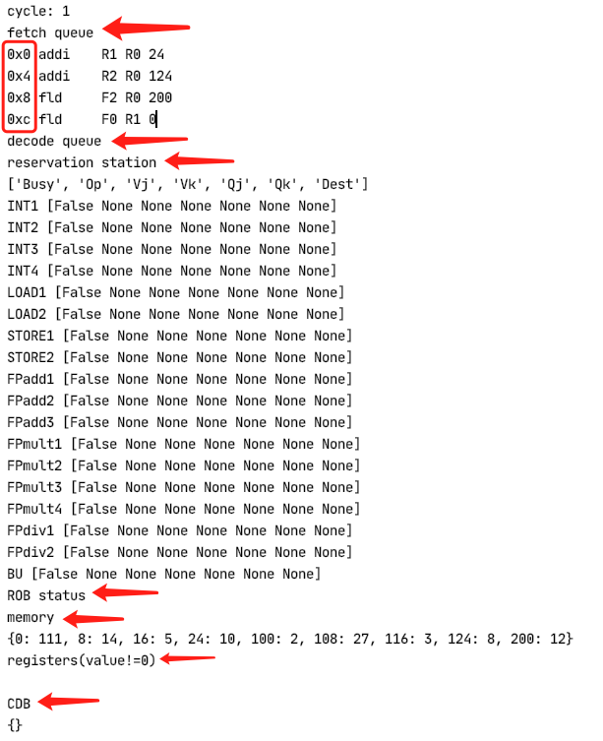

This figure illustrates the case of cycle=1 when the program starts running.

There are four instructions in the fetch queue, and the red box indicates the address of the instruction.

Because cycle=1, decode queue is empty, ‘Busy’ in reservation station is also false, ROB status is also empty, memory is read from memory content file. And the program only print registers whose value is not 0. The CDB is currently also empty.

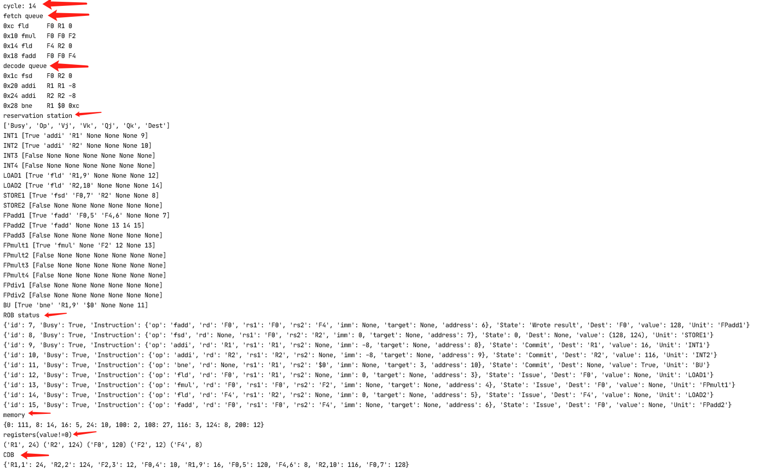This figure illustrates the case of cycle=14 when the program is running

There are 4 instructions in the fetch queue and 4 instructions in the decode queue. The row where busy is true in the reservation station indicates that the function unit is occupied. ROB status will update the state of the item in order. In the common data bus. "R1, 1":24 means that the instruction with the ID of 1 modifies the value of R1 to 24. The purpose of adding the ID is to allow the instruction to get the value it depends on through the CDB.

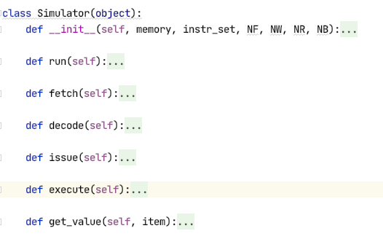

This is the definition of simulator. I created four methods of fetch, decode, issue, and execute for the simulator object to simulate the process. The state whose state is M will be processed in the execute function. And function get_value is for the calculation of the instruction result.

1. **Comparative Analysis**

When NF=4, NW=4, NR=16, NB=4, total cycle is 38,

1) When NF=4, NW=2, NR=16, NB=2, total cycle is 39,

Since NW=2, the simulator issues two instructions at most each time, so it takes more cycles.

2) When NF=2, NW=4, NR=16, NB=4, total cycle is 39,

Since the decode queue is infinite and NW=4, the simulator will be hungry, which costs more cycles.

3) When NF=4, NW=4, NR=4, NB=4, total cycle is 48,

When NF=4, NW=4, NR=8, NB=4, total cycle is 38,

When NF=4, NW=4, NR=32, NB=4, total cycle is 38,

The conclusion is that when NR is greater than 8, it means that ROB will not be full during operation, so when NR is greater than 8, its effect is the same as NR=32. When it is equal to 4, it means that the ROB will be full during operation, so more cycles of stall are needed.